16.5 Carboxylic acid
Name: ____________________ Class: ____________________ Due date: 3.11
1. General formula: CnH₂n+1COOH ， -COOH is called carboxyl group
1. Which structure shows a carboxylic acid? （ ）
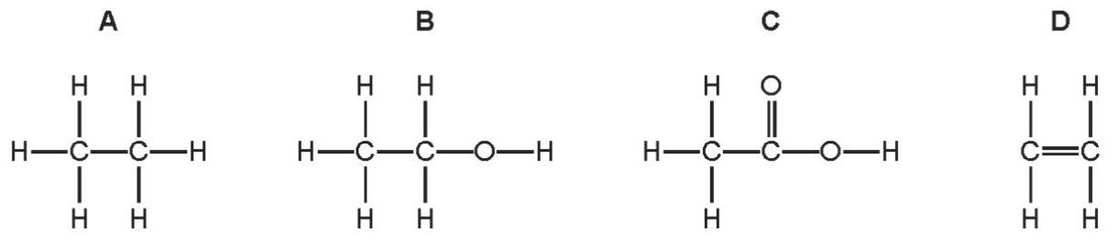

2. Which two compounds are molecules which both contain a double bond? （ ）
A ethane and ethanoic acid
B ethane and ethanol
C ethene and ethanoic acid
D ethene and ethanol

3. Molecule X is both an alkene and a carboxylic acid.
Which row describes X? （ ）
 | saturated | COOH present
A | no | no
B | no | yes
C | yes | no
D | yes | yes

4 .Which statements are correct for ethanoic acid? （ ）
1 It contains a carbon- oxygen double bond.
2 It contains two carbon atoms.
3 It decolourises bromine water.
4 It contains an - OH group.
A 1 and 2 only B 1 and 3 C 1, 2 and 4 D 2, 3 and 4

2. Formation of carboxylic acid
5. A solution of ethanol and water is left to stand in an open beaker in a warm room for three weeks.
Which statement explains what happens to the ethanol in the solution? （ ）
A The ethanol is dehydrated to ethene.
B The ethanol is hydrolysed to ethene.
C The ethanol is oxidised to ethanoic acid.
D The ethanol is reduced to ethanoic acid.

6. Which reaction can be used to make ethanoic acid? （ ）
A oxidation of ethanol
B oxidation of ethene
C reduction of ethanol
D reduction of ethene
3. Properties of carboxylic acid
7. An organic compound, P, reacts with zinc to produce a gas, Q.
What are P and Q? （ ）
 | P | Q
A | ethanoic acid | carbon dioxide
B | ethanoic acid | hydrogen
C | ethanol | carbon dioxide
D | ethanol | hydrogen

8. Which statement describes the compound shown below? （ ）
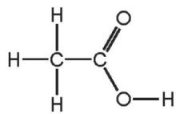
A It is a colourless flammable gas.
B It is a liquid which decolourises bromine water.
C It is a liquid with a characteristic smell.
D It is formed when ethane reacts with steam.

9. Which statement about ethanoic acid is correct? （ ）
$−C_{2}H_{5}$A It contains a group.
B It is a strong acid.
C It is formed by the reduction of ethanol.
D It reacts with alcohols to form esters.

10. Which statement about aqueous ethanoic acid is correct? （ ）
A It reacts with metal carbonates to form salts, hydrogen and water.
B It reacts with metal oxides to form salts and oxygen.
C It reacts with reactive metals to form salts and hydrogen.
D It turns damp red litmus paper blue.

11. Which statements about aqueous ethanoic acid are correct? （ ）
1 It is an alkane.
2 It reacts with sodium carbonate to form carbon dioxide.
3 It changes the colour of litmus solution from blue to red.
4 It is a hydrocarbon.
A 1 and 2 B 1 and 4 C 2 and 3 D 3 and 4

${CH}_{3}{−CH}_{2}−COOH$12. Propanoic acid is a carboxylic acid. Its formula is
Propanoic acid is the third member of the homologous series of carboxylic acids.
Give the name and structural formula of the fourth member of this series.
name ............................................................................................................................
formula .....................................................................................................................[2]
ii.Members of a homologous series have very similar chemical properties.
State three other characteristics of a homologous series.
...................................................................................................................................................................................................................................................................................................................................................................................................................[3]
Carboxylic acids can be made by the oxidation of alcohols.
Draw the structural formula of the alcohol which can be oxidised to propanoic acid. Show all atoms and bonds.

[1]
ii.Name a reagent, other than oxygen, which can oxidise alcohols to carboxylic acids.
...................................................................................................................................[2]
c.Complete the following equations for some of the reactions of propanoic acid.
The salts of this acid are called propanoates.
$→$(i zinc + propanoic acid hydrogen................................................................ [1]
$→$ii.calcium oxide + propanoic acid ...................................................................[1]
$LiOH+CH_{3}CH_{2}COOH→$iii. ...........................................................[1]

$55.85\%$$6.97\%$$37.18\%$13 . A compound, X, contains carbon, hydrogen and oxygen.
(i)How does this prove that compound X contains only carbon, hydrogen and oxygen? ....................................................................................................................[1]
(ii)Use the above percentages to calculate the empirical formula of compound X.
.......................................................................................................................................
...................................................................................................................................[2]
$M_{r}$The of X is 86. What is its molecular formula?
.......................................................................................................................................
Bromine water changes from brown to colourless when added to X.
What does this tell you about the structure of X?
.......................................................................................................................................
.......................................................................................................................................
ii.Magnesium powder reacts with an aqueous solution of X. Hydrogen is evolved.
What does this tell you about the structure of X?
.......................................................................................................................................
.......................................................................................................................................
iii.X contains two different functional groups. Draw a structural formula of X.

14. Ethanol can be oxidised to form ethanoic acid.
d.Name a suitable oxidising agent for this reaction.
................................................................................................................................[1]
ii.A molecule of ethanoic acid has the structure shown.
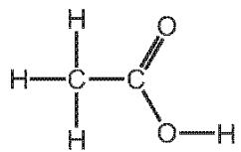
Complete the dot- and- cross diagram to show the electron arrangement in ethanoic acid. Show outer shell electrons only.
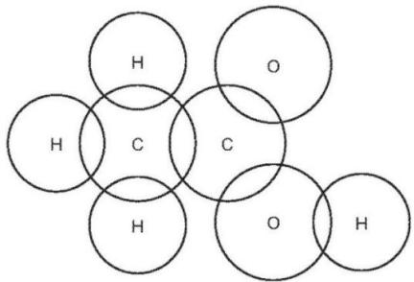
[3]
ii.Describe how you could show that ethanoic acid is a weaker acid than hydrochloric acid.

e. Carboxylic acids react with alcohols to make esters.
The structure of an ester is shown.
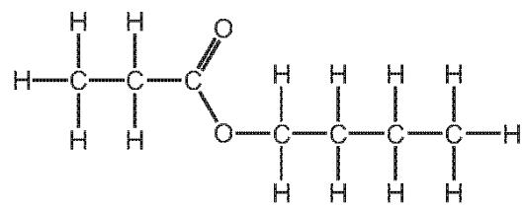
Draw the structures of the carboxylic acid and alcohol from which this ester can be made. Give the names of the carboxylic acid and alcohol.
structure of the carboxylic acid :

name of the carboxylic acid ...........................................................................................
structure of the alcohol :

name of the alcohol...............................................................................................

